The United Benefice of Sharnbrook, Felmersham
and Knotting with Souldrop
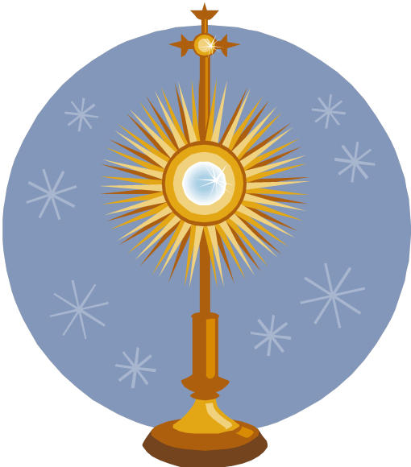
www.SharnbrookCofEChurches.org

Holy Hour
60 mins of silent prayer in Advent
The privilege of 60 mins prayer with Jesus in the Blessed Sacrament. Come lay your burdens, worries, hopes, fears, needs, anxieties before Jesus…….. receive his grace in your life and allow the healing and forgiveness to flow– pop in for all of the 60mins or just as many as you can manage, everyone welcome!

The Rector: Rev'd Fr Reuben Preston SCP OblOSB
01234 782000 / 07971 895897 rectorofsharnbrook@rjpmedia.co.uk
What is Holy Hour?
All Christian traditions recognize that something special happens in Holy Communion. We meet intimately with Christ in the bread and the wine of the altar. Christ feeds us and dwells with us spiritually. He is very present to us life a best friend beside us. Holy Hour is an invitation to come into the presence of Jesus in the Blessed Sacrament – the bread and wine of the altar. We just come with our whole life and sit with the Lord. Sometimes you will want to pray in your heart or mind and sometimes you will just want to share the time with Jesus.

Music
This Holy Hour has music from the album of David Haas Give me Jesus
The approximate times are:
7.00pm Look to Christ
7.08pm Here in This Place
7:17pm Jesus, Be with Us Now
7:28pm All I Want
7:40pm Present Among Us
7:52pm You Are God's Work of Art

What should I do?
You have come to spend time with God.
Jesus Christ is present to us in the Blessed Sacrament sit or kneel with him and allow yourself to dwell in the presence of your God.
You are in the loving gaze of God.
Just talk about the things that are on your heart tonight – the good and the bad, the pleasing and the embarrassing – God knows it all anyway!
Allow yourself to be bathed in the loving gaze of God.

Anima Christi
Soul of Christ, sanctify me.
Body of Christ, save me.
Blood of Christ, inebriate me.
Water from the side of Christ, wash me.
Passion of Christ, strengthen me.
O Good Jesus, hear me.
Within your wounds hide me.
Permit me not to be separated from you.
From the wicked foe, defend me.
At the hour of my death, call me
and bid me come to you
That with your saints I may praise you
For ever and ever. Amen.
How was the time for you?
How did you find yourself using the time?
Did God feel close or distant?
How did that change?
What prompted that?
How might you draw closer to God?
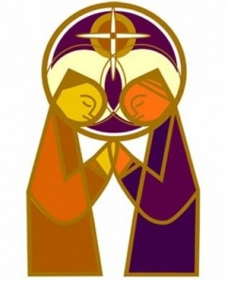
These are all questions that will help you in reaching closer to God. You may find it helpful to talk about some of these questions with someone.
Why not ask Fr Reuben to spend a little time with you thinking about these questions? He will be able to assist you in your next steps in prayer. This sort of conversation is called Spiritual Direction : Fr Reuben is a trained and practising Ignatian Spiritual Director.

