A
N O W Y O U K N O W M E D I A
S T U D Y G U I D E

What Does It Mean to Be Saved?: The Theology of Salvation

Presented by Fr. André Brouillette, S.J., Ph.D., S.T.D.

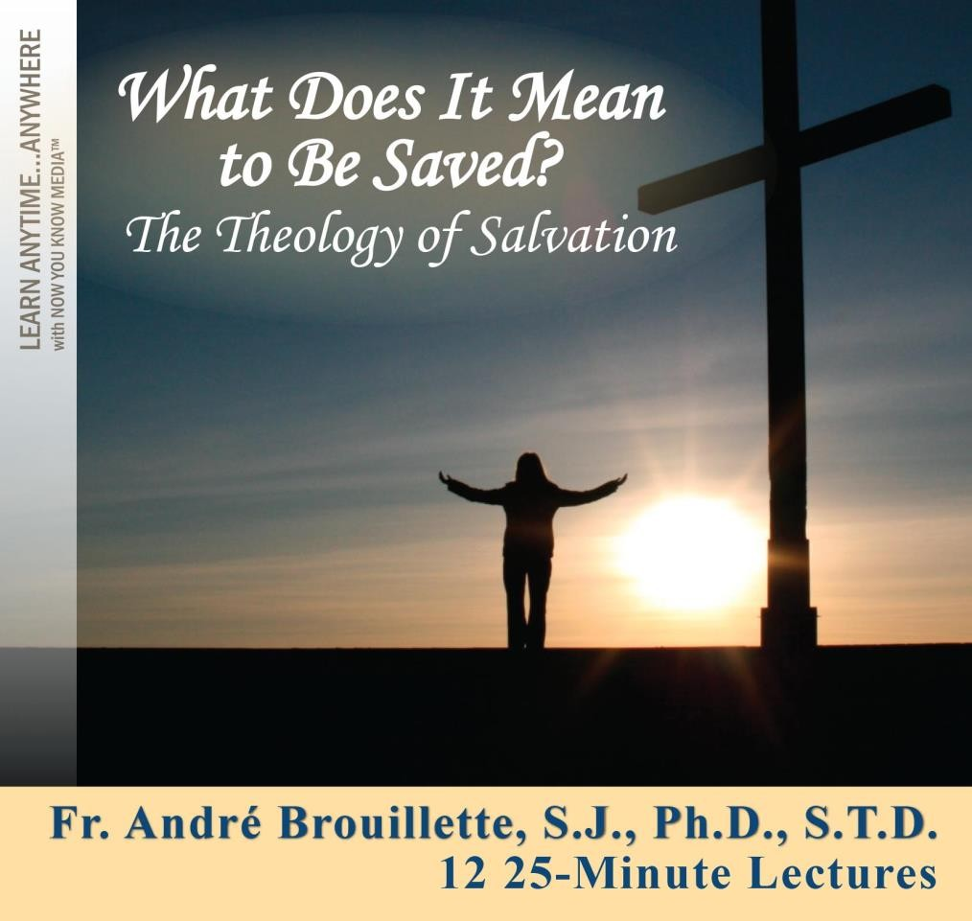

Now You Know Media
Copyright Notice:

This document is protected by copyright law. ALL RIGHTS RESERVED. You are permitted to view, copy, print, and distribute this document (up to seven copies), subject to your agreement that: Your use of the information is for informational, personal and noncommercial purposes only. You will not modify the documents or graphics. You will not copy or distribute graphics separate from their accompanying text and you will not quote materials out of their context. You agree that Now You Know Media may revoke this permission at any time and you shall immediately stop your activities related to this permission upon notice from Now You Know Media.

Fr. André Brouillette, S.J. Ph.D., Université Laval in Quebec City S.T.D., Institut Catholique de Paris
Boston College School of Theology and Ministry

r. André Brouillette, S.J., Ph.D., S.T.D., teaches Systematic and Spiritual Theology at the Boston College School of Theology and Ministry, where he also serves as Director of the Sacred
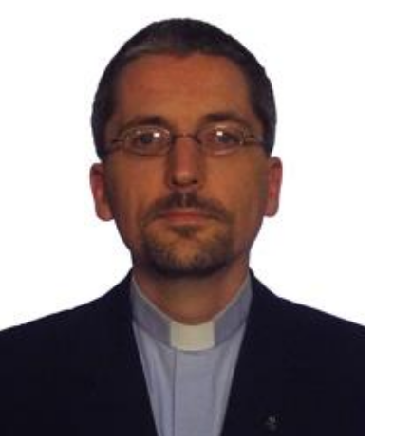heology Licenciate program. A Jesuit priest from Quebec, Fr. rouillette received a bachelor’s degree in philosophy from the Centre èvres in Paris, an M.A. in philosophy from the Université de Montréal, d an M.A. in history from the University of Toronto. He then taught hilosophy and Church history in Port-au-Prince, Haiti, at the Grand éminaire Notre-Dame and the School of Theology for Religious. He ceived a Master of Divinity from the Weston Jesuit School of Theology

T
B S an p S re
F
in Cambridge, Massachusetts, and a Licentiate in Sacred Theology from the Boston College School of Theology and Ministry.

Fr. Brouillette then earned a Doctorate in Sacred Theology summa cum laude from the Institut Catholique de Paris, as well as a Ph.D. from the Université Laval in Quebec City. His dissertation explored the role of the Holy Spirit for salvation through the lens of the writings of St. Teresa of Ávila. It was published as a book in the prestigious series Cogitatio Fidei under the title Le lieu du salut: Une pneumatologie d’incarnation chez Thérèse d’Ávila (Editions du Cerf). He has published articles in various languages and lectured internationally.

Table of Contents

Course Information

Presenter Biography………………………………………………………………….i

Course Overview ......................................................................................................... 1

Course Materials

Lecture 1. Introduction: Framing the Discussion ........................................................ 2

Lecture 2. Salvation For: The Testimony of the Saints ............................................... 5

Lecture 3. Models, Mediation, and Moments .............................................................. 8

Lecture 4. Salvation as Revelation ............................................................................ 11

Lecture 5. Salvation as Redemption: Christus Victor ............................................... 14

Lecture 6. Salvation as Liberation ............................................................................. 17

Lecture 7. Salvation as Justification .......................................................................... 20

Lecture 8. Salvation as Sacrifice and Expiation ........................................................ 23

Lecture 9. Salvation as Reconciliation ...................................................................... 26

Lecture 10. Salvation as Deification.......................................................................... 29

Lecture 11. The Extent of Salvation .......................................................................... 32

Lecture 12. Conclusion: Salvation as Features and Prayer! ...................................... 35

Supplemental Materials

Bibliography .............................................................................................................. 38

Course Overview

Explore the power and mystery of salvation.

Christianity is a religion of salvation, and Christ is the Savior—but what does it mean to be saved? This course offers you a theologically rich and deeply meaningful examination of this vital question. In the New Testament and throughout history, powerful images and models have been used to describe the event of salvation. When examined together, these images and models sketch a wide field of meaning about salvation.

Now, in What Does It Mean to Be Saved?: The Theology of Salvation, you will systematically explore these powerful images. Through these 12 brilliantly taught lectures, you will gain a much-enhanced understanding of salvation. You will examine such models as revelation, redemption, liberation, justification, expiation, reconciliation, and deification.

You will explore many of your most important salvation questions, such as: What is salvation? Who saves—and who is saved? What are we saved from and for? What is the role of Christ in salvation? When is salvation achieved? And, most importantly, how is one saved?

As Prof. Brouillette examines these questions and many others with you, you will encounter profound new insights into the Christian tradition. Your journey will be grounded in the biblical testimony about salvation, especially in the New Testament. You will also draw on insights from theologians, old and new, the Magisterium of the Church, the saints, the Church Fathers, the liturgy—and even culture and the arts! Although you will focus on the Roman Catholic tradition, you will also engage in dialogue with Eastern Christian theology and Protestantism.

On your journey, the depth and the breadth of the mystery of salvation will unfold before you, revealing how the union with the Trinitarian God is at the heart of being Christian. Exceptionally well-taught, this course will reignite your faith.

Lecture 1. Introduction: Framing the Discussion

Overview

alvation is a multifaceted reality. The richness of that notion is highlighted by the different images, metaphors, and models that have been developed around salvation. To frame our exploration, we will look at some dimensions and definitions of salvation. Through the bestowal of the title of
Savior to Christ, the New Testament offers us important insights regarding salvation. One way to look at salvation is to raise this question: What are we saved from?
S

I. What is Salvation? Definitions and Dimensions

• Salvation as mystery.

Many perspectives: is this an opportunity or problem?

• Various dimensions of salvation can be considered:

Is it a moment (event), or is it inscribed in a continuum (movement)? Does it pertain to the past, the present, or the future?
What are its modalities:

(i) What are we saved from and for? (ii) How are we saved?
(iii) How is salvation mediated to us? Who are the players involved:
(i) The role of the individual

(ii) The place of the community or the Church

(iii) The role of the Trinity

II. Soteriology

• The theology of salvation (soteriology) can draw on many sources in its theological imagination:
rationality, aesthetics (images, metaphors), liturgy, and the sacraments.

• The vocabulary of salvation: salvation, redemption, atonement.

Salvation is the broader term, and does not refer to a specific soteriological “model.”

Redemption can be synonymous with salvation, but also has very distinct roots.

Atonement is equivocal, since it can pertain to sacrifice, to reconciliation, or to salvation in broad terms.

• The concept of “salvation” in the Bible:

In the New Testament, the title of “Savior” is given to Jesus Christ.

Salvation has clearly a religious meaning, but sometimes with an overtone of “health,” as if
to cure.

(i) The vocabulary of salvation in the New Testament is not linked to a specific mechanism
(unlike redemption or sacrifice).

• The relationship between Christology and Soteriology:

Since Christ is Savior, the study of salvation devotes a lot of attention to the study of the person of Christ (Christology).

III. Salvation From

• The idea of salvation begs the question, “What are we saved from?”

This raises the issue of evil, sin, and death.

• Do we need (or desire) salvation? The question of the offer of salvation in a saturated and autonomous world.

• God requires a breach, an entry way, a void, in human beings for that offer of salvation to seize us.

Reflection Questions

1. The issue of salvation can be addressed from various perspectives, even in the Bible. How can such openness be an opportunity?

2. How are the words related to salvation (e.g., to save, Savior, etc.) used in the New Testament?

3. One way to look at salvation is to ask the question: “what are we saved from?” What would be
things or situations that we need to be saved from?

Lecture 2. Salvation For: The Testimony of the Saints

Overview

alvation is not only a rescue from a negative situation, be it sin or any type of enslavement. Salvation is “teleological,” in the sense that it pushes forward, towards a goal. The complete revelation of salvation is beyond our reach, but since salvation does not pertain only to the future,
the present experience of closeness to God of individuals can help us approach salvation. Who could teach us in that regard better than saints? Thus, we will look at the salvific journey of two great women: St. Teresa of Ávila and Mother Teresa of Calcutta.
S

I. Achieved Salvation

• What does (achieved) salvation look like?

Salvation does not simply extract us from some (negative) situation, but attracts us towards something.

The “end” of salvation is not so much a place, but rather a relationship: (i) The “end” is life with/in God.
The saints, as women and men recognized by the Church for their proximity with God, can teach us through their lives what salvation looks like, what we are hoping for in salvation.

II. Introducing Teresa of Ávila and Mother Teresa of Calcutta

• The two saints we will be looking at are Teresa of Ávila
(1515–1582) and Mother Teresa of Calcutta (1910–1997).

Teresa of Ávila is a Carmelite nun from Spain, who established reformed Carmelite monasteries and was a great spiritual writer.

(i) She was the first woman to be declared a Doctor of the Church, in 1970.

Teresa of Calcutta was a missionary sister in India.
After a profound spiritual experience, her life took a new direction, and she established the Missionaries of Charity to take care of the most vulnerable human beings.

(i) Ten years after her death, some of her private writings were published, offering insights into her spiritual journey.

Teresa of Avila by François Gérard, 1827

• The salvific journey of Teresa of Ávila:

Already in her childhood, Teresa desired to enjoy God “forever.”

Teresa became a nun, but was lukewarm for many years, until she engaged in a journey of conversion after being moved by the view of a statue of Christ whipped.

Her journey towards closeness to God led her to espouse God’s desire for the salvation of
others and to work for it. It started with a compelling vision of hell!
• The salvific journey of Mother Teresa of Calcutta: Mother Teresa left Europe at the age of 18 as
a young nun to become a teacher in India. She served in that capacity for many years.

On a train ride in 1946, she experienced a “call within a call” to satiate the thirst of Jesus and serve the poorest of the poor.

(i) It led to the foundation of the
Missionaries of Charity.

After an initial period of spiritual warmth, she experienced a long period of deep
spiritual dryness, amidst a very successful apostolate. She modeled the thirst of Christ that she wanted to satiate.

III. Features of Salvation
Mother Teresa of Calcutta. Photo by Robert
Pérez Palou (CC BY 3.0)

• From the experience of these two saints, some features of salvation stand out: Salvation allows for conversion and growth.
The initiative is God’s, but human beings have to cooperate.

For Teresa of Ávila, the images of heaven and hell illustrate the contours of salvation and its importance.

Salvation entails proximity and union with God, which could be experienced in different ways (even through darkness).

Christ is pivotal in their relationship with God, but also to model the mission such relationship impels.

Reaching out for the others, caring for the salvation of others, is part of what closeness with
God would entail.

Reflection Questions

1. Why could the saints teach us something about salvation?

2. What are some significant characteristics of the journey of salvation of Teresa of Ávila and Teresa of Calcutta?

3. Since salvation is rooted in one’s relationship with God, how should that relational quality shape our understanding of what it means to be saved?

Lecture 3. Models, Mediation, and Moments

Overview

lready in the New Testament, different images and concepts were used to explain salvation, as new creation, justification, sanctification, glorification, and redemption. Some of those images were based on or developed into proper models. At the heart of each model stands Christ.
Through his person––both divine and human––salvation is mediated to humanity. In the assessment of salvation, some “moments” of the life of Christ can be either emphasized or overlooked. A healthy soteriology embraces both the Incarnation and the Passion.
A

I. Introduction

• It is important to examine the vocabulary and various “models” of salvation.

• Rarely do we find in the New Testament a “pure” salvific model; models and images tend to complement each other.

Contemporary theological texts do the same.

• But not all models are identical either; they are singular.

They often have different historical roots, and will highlight specific elements of the process of salvation.

Not all images would develop into full-fledged models.

• Various categorizations of the different models are offered by scholars (e.g., Sesboüé, Daley).

II. The Mediation of Christ

• In 1 Timothy 2:5-6, a condensed statement of faith presents Christ as mediator.

For there is one God; there is also one mediator between God and humankind, Christ Jesus, himself human, who gave himself a ransom for all. (1 Timothy 2:5-6a NRSV)

• In the Letter to the Hebrews, the mediation of Christ unfolds through the language of high priest––
Christ is the new high priest and mediator of a new covenant.

• The two natures of Christ, as human and divine, are essential to think of the exchange achieved in him with humanity as a whole.

III. Incarnation and Passion

• The idea of saving “moments” brings up the tension between Incarnation and Passion.

• Theologians have sometimes emphasized unilaterally the salvific significance of one moment of the life of Christ over the other.

The theology of the West, in the last centuries, has often focused on the death of Christ.

The Church Fathers, and the Eastern Church in their wake, assign a great importance to the
Incarnation.

• The salvific import of the life of Jesus Christ should be seen in the full spectrum, from the
Incarnation to his death, resurrection, and Ascension, and even Pentecost.

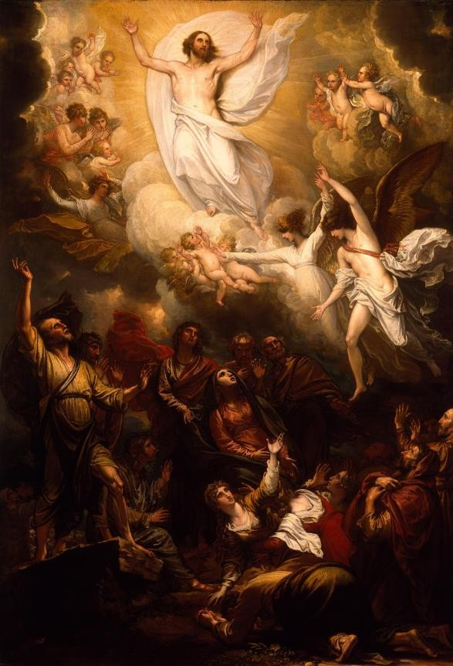

The Ascension by Benjamin West, 1801

Reflection Questions

1. Identify some images or models of salvation.

2. What are some ways in which we could look at Jesus Christ as Mediator?

3. Why were the Incarnation and the life of Christ so important for the soteriology of the Church
Fathers?

Lecture 4. Salvation as Revelation

Overview

alvation is not only about something being achieved, but also about something being made known and being shown! The presentation of salvation as revelation entails the exploration of the realm of aesthetics; how does the “image” play in our human nature, in our understanding of Christ and
his message, as well as in our salvation. We will draw on the Eastern tradition of the icon, as well as the seminal theological work of St. Athanasius, On the Incarnation.
S

I. Introduction

• The beginning of the First Epistle of John underlines how the Word was embodied in Christ, as well as heard, seen, and touched.

We declare to you what was from the beginning, what we have heard, what we have seen with our eyes, what we have looked at and touched with our hands, concerning the word of life—this life was revealed, and we have seen it and testify to it, and declare to you the
eternal life that was with the Father and was revealed to us—we declare to you what we have seen and heard so that you also may have fellowship with us; and truly our fellowship is with the Father and with his Son Jesus Christ. We are writing these things so that our joy may be complete. (1 John 1:1-4 NRSV)

• Revelation pertains both to making something known by uncovering or unveiling (knowledge), and
to “showing” something or someone, making it visible (image).

The figure of the light often accompanies such dispelling of ignorance or darkness.

God’s Revelation follows the same pattern, since Revelation is not simply equated with
content or words (not even the Bible), but is also the very act by which God self-reveals.

II. Seeing and the Icon

• Images influence and shape us, even from an anthropological perspective.

• In Christianity, images are not an “afterthought” of faith, for the Word became incarnate––visible.

• Images have been used in the Roman Catholic Church in various shapes and forms throughout history.

• In the Eastern spirituality and theology, however, the art of the icon occupies a special place in the life of the Church, and, as such, is venerated.

III. Jesus as the “Revealer”

• Christ the teacher brings “knowledge” about God and salvation.

• Jesus Christ is revealed in his identity through theophanies––manifestations of God (e.g., Christ’s
Baptism and Transfiguration).

To Christ, the metaphor of light can be applied, since he dispels darkness.

Christ is not only teacher, he is knowledge of God, salvation, truth incarnate. The “I am”
sayings of John’s Gospel bear witness to such embodiment.

• Seeing God in Jesus Christ calls for a response in faith, like the centurion who, after having
witnessed Jesus’ last hours recognized that he was the Son of God (Mark 15:39).

• Christ reveals human beings to themselves by showing them how to live a humanity fully attuned to divinity.

IV. Athanasius and the Image of God

• Athanasius is an important Church Father from the 4th century, participant in the Council of Nicaea
(325), and bishop of Alexandria (Egypt).

In his treatise On the Incarnation, he underlines the importance of the Incarnation to understand the salvation God brought to humanity in Jesus Christ.

Athanasius presents the salvation by Christ as a restoration, or re-carving, of the image of
God in human beings.

Athanasius of Alexandria

Reflection Questions

1. What does Revelation mean? Is it simply about content being transmitted?

2. In what way can Jesus Christ be considered a “Revealer”?

3. In the light of salvation, what is the importance of the “image of God” for St. Athanasius?

Lecture 5. Salvation as Redemption: Christus Victor

Overview

edemption is a term that is often used as the overarching term for salvation. Its roots are very distinct in the Old Testament, since it draws principally on the experience of the Israelites of being brought out of a situation of slavery in Egypt through the hand of God. In that process,
they were also constituted as a new reality, God’s people, and led towards the Promised Land. Christ assumes the mantel of redemption, and elements of redemptive vocabulary are used to describe Christians as “bought back” at a price or ransom, highlighting our costly departure from slavery through the victory of Christ.
R

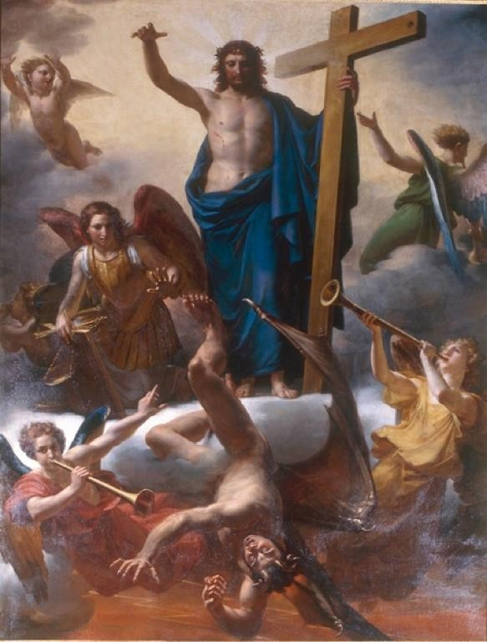I. Redemption and Christus Victor

• Jesus Christ as Redeemer

Etymologically, to redeem means to “buy back,” to
bring out of slavery.

In the redemption model of salvation, the focus is both
on the person of the Redeemer, and on the situation from which one is redeemed.

• Jesus Christ as “Victor”

In the writings of the Church Fathers, in John’s Gospel, and in some medieval depictions, we find the presentation of Christ as “Victor,” as the one who vanquishes sin, death, and the devil through the cross.

II. Old Testament Redemption

• The roots of the notion of redemption lie in the Old Testament.
The Spirit of Evil Is Hurled into the Abyss After the Arrival of the Messiah by Guillaume-Francois Colson, 19th c.

• Three important sources for the understanding of redemption in and Old Testament key are: The Exodus story from Egypt with Moses.
The hoped-for messianic redemption.

The institution of the “go’el” or kinsman redeemer (cf. Leviticus 25). (i) See also the story of Ruth and Boaz in the Book of Ruth.

III. New Testament Redemption

• The notion of redemption is also found in the New Testament.

• Jesus is never given the title of “Redeemer” in the New Testament, but he is nevertheless called our
“Redemption.”

• Redemption:

The word redemption (apolutrôsis) can refer both to God’s saving deeds for his people, and to the eschatological hope of the redemption of Jerusalem; thus it encompasses both the past and the future.

Redemption is sometimes aligned with the realm of expiation and sacrifice (e.g., forgiveness of sins, purification).

• Purchase or buying back:

Christians are sometimes portrayed as having been “bought back,” or “bought at a price” (1
Corinthians 6:20), to signify the costliness of our redemption.

In Galatians 3:13-14, Paul mentions that we have been “bought back” by Christ in order to
receive the Spirit.

(i) By being bought out of slavery, Christians are invited to live a new life as member of the Body of Christ, and also as part of a new people, God’s people through filiation. Receiving the Spirit, we become part of God’s family.

• Ransom:

Although the theme of the ransom is not prominent in the New Testament (Matthew 20:28, Mark 10:45, 1 Timothy 2:6), it acts as a prolongation of the idea of the “price” paid for our salvation.

Some Church Fathers pushed the metaphor further by asking, “To whom was the ransom paid?”

Reflection Questions

1. What are some roots of the concept of redemption found in the Old Testament?

2. How is the vocabulary of redemption used in the New Testament?

3. What could be examples of enslavement in our world that we need to be redeemed from?

Lecture 6. Salvation as Liberation

Overview

he model of salvation as liberation is a trendy one today. Liberation, with its emphasis on freedom, speaks to a contemporary audience. A cousin to redemption, sharing similar biblical roots, it has blossomed as liberation theology. As such, liberation came to incarnate the integrality
of salvation offered by Jesus’s mission statement at the synagogue of Nazareth. Liberation theology emphasizes the “now” of salvation, an historical present rooted in various contexts, concerned with social justice, and harboring a special care for the poor.
T

I. Introduction to Liberation

• The model of liberation shares some of its roots with that of redemption, yet the two are not synonymous.

Liberation emphasizes the positive side of salvation, the orientation towards freedom.

Redemption focuses more on the negative aspect from which we are saved, the departure from slavery.

• Recent decades have seen many movements, inside and outside the Church, taking the mantel of liberation.

II. Biblical Roots

• The Exodus story, with its powerful narrative towards freedom and the constitution of a people, is the foundational story for liberation.

• The prophetic institution, with its denunciation of injustice, especially in regard to the poor, is also an inspiration for liberation theology, because of its embodied view of salvation.

• Jesus’s appropriation of the words of Isaiah in the discourse at the synagogue of Nazareth (Luke 4:16-21), about bringing liberty to captives or the oppressed, also points to the integrality of salvation, and its present character.

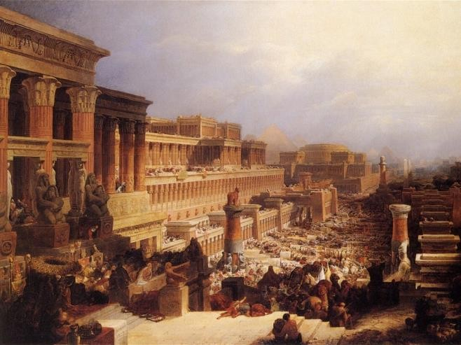The Israelites Leaving Egypt by David Roberts, 1828

• Another way to ground liberation is to look at Jesus as the free human being par excellence, through his life among us.

III. Liberation Theology

• As a proper theology concerned with salvation, liberation theology emerged and blossomed in the context of the 1960s–1970s––an era of social changes and great hopes––in the Church and in the world. It could also draw on the resources of the Catholic Social Teaching.

• Liberation theology highlights several features which enrich the understanding of salvation: The integrality of salvation
The attention to the context

The care for the poor

The collective dimension of salvation

The consideration of structural or social sin

(i) Speaking beyond the individualistic nature of sin, how we normatively treat the topic

The emphasis on the actuality of salvation (today!) The recovery of prophetic denunciation
The call to transform society

• Praises and critiques from the Congregation for the Doctrine of the Faith:

In 1984 and 1986, the Congregation for the Doctrine of the Faith issued two documents to assess the good in liberation theology, and also note its limitations (e.g., elements of Marxist analysis).

• The figure of Gustavo Gutiérrez:

A Peruvian parish priest, theologian, and spiritual author, Gustavo Gutiérrez embodies the renewal in Christian life brought through Liberation theology.

Reflection Questions

1. What are the similarities between salvation as liberation and as redemption, especially regarding their biblical roots?

2. What does the idea of “integral salvation” proposed by liberation theology entail? What would be examples of non-integral salvation?

3. Which characteristics of the liberation model of salvation attract you in particular?

Lecture 7. Salvation as Justification

Overview

he soteriological model of justification is both richly biblical and historically polemical! In the New Testament, Paul develops the idea of our “justification” through Christ, who restored us to the righteousness God intended for us. In the 16th century, Martin Luther gave to that model a
canonical value, making it into a theological litmus test for the Reformed Church. The Council of Trent responded to the Protestant critique by formulating its own understanding of God’s work of salvation as justification.
T

I. Introduction

• Because of its importance in the Protestant Reformation instigated by Martin Luther, and its response by the Council of Trent, the soteriological model of justification often epitomizes controversies.

• In its Biblical understanding, justification pertains more to “righteousness” (see the Greek dikaios, righteous) than to justice.

• In Catholic theology, justification is sometimes used to describe the receptive dimension of salvation by the believer.

II. Justification in a Nutshell

• The workings of justification can be construed in the context of three elements: Sin constitutes a disorder incompatible with justice or righteousness.
The centrality of Christ’s agency, especially through the cross.

This divine offer is appropriated by faith.

III. Paul’s Theology of Justification

• In the Old Testament, righteousness (dikaiosunè) is depicted as a quality pertaining to God.

• In the New Testament, the main author who treats justice and righteousness in a soteriological key is St.
Paul, especially in his Letter to the Romans.

• Four elements of Paul’s theology of justification can be highlighted:

Christ is taking the central stage; he is the one bring about justification.
Justification is God’s action and initiative, offered freely. God desires to make us righteous because he is righteous. The gift of righteousness has to be received by faith.

IV. A 16th c. Debate: Luther’s Theology of Justification

• Reading the Pauline epistles had a tremendous impact on the theological evolution of Martin Luther.

• Luther considers justification an essential component of the Christian faith, the articulus stantis vel cadentis Ecclesiae, the article upon which the Church stands or falls.

For him, the gift of justification is to be received in faith
alone; works have no part in it.

His anthropology is somehow pessimistic, considering that the human being is always at once righteous and sinner (simul justus et peccator).

• Christ’s role in his theology of justification is centered primarily on
the cross (theologia crucis).

V. The Response of the Council of Trent

Martin Luther by Lucas the
Elder Cranach, 1529

• The Decree on Justification by the Council of Trent is one of the few magisterial documents exposing the Catholic understanding of salvation.

For Trent, faith is the “sole foundation for justification” (chap. 8), following Paul’s lead and Luther’s insight. But, although faith is the foundation for justification, it is prepared by a grace coming from the Holy Spirit, and called to grow.

(i) Trent has a subtle way of understanding justification by faith; it is not a disjunctive moment, happening once in a life time, but is seen in a continuum.

Trent displays a positive anthropology that prizes and upholds free will, and a genuine human agency.

Works are not cast out, nor are they put on the same footing as faith for the reception of justification. Good works are signs of one’s desire to persevere and grow in righteousness.

• In 1999, Lutherans and Catholics reached a theological agreement on the theory of justification, almost 500 years after the beginning of the Protestant Reformation.

Reflection Questions

1. What explains the historical importance of the model of salvation as liberation?

2. What does the Bible say about justification? Is it similar to God’s judgment?

3. What is the Catholic position vis-a-vis Luther’s challenge about the relationship for salvation of faith and works?

Lecture 8. Salvation as Sacrifice and Expiation

Overview

acrifice is a loaded concept. Misunderstood, misconstrued, it could hide more than reveal! Many Christians would prefer to abstain from such vocabulary altogether, but its biblical and liturgical roots are deep and varied. The pitfalls of sacrifice should be acknowledged, but also the ways in
which a renewed understanding is blooming, especially in regard to its origin in the very life of the Trinity. We will look explicitly both at the Old Testament roots of that concept, and its New Testament unfolding.
S

I. Introduction

• The common usage of the vocabulary of sacrifice often obscures the meaning of Christian sacrifice.

Sacrifice and expiation pertains to a cultic imagery present in the Old Testament, it relates to sin, offering (e.g., victim, blood), and purification.

• Issues and excesses around sacrifice:

Concerns about the vocabulary of sacrifice revolve mostly around its violent imagery, and the rhetorical excesses it engendered, even in theological discourse.

• Christian sacrifice seen from the Trinity:

Theologian Robert J. Daly suggests the vantage point of the Trinitarian life and the self-gift there deployed among the Trinitarian persons as the standing ground to understand Christian sacrifice.

The Trinitarian movement of self-offering sheds light on the life, death, and resurrection of Christ. Through the Spirit, believers can respond to Christ’s sacrifice by entering themselves into that movement of self-gift.

II. Expiation and Sacrifice in the Old Testament

• Sacrifice as a response to the need for purification:

Sacrifice was considered a means of expiation, and was part of religious life.

Sacrifice was understood as necessary because of the awareness of God’s holiness, and
because of a concern with sin, which led to an unquenchable desire for purification.

• A move towards the interiority:

Already in the Old Testament, sacrifice was not seen only as an extrinsic ritual; the inner disposition of the person offering the sacrifice was important, as was prayer.

• Two important figures of bearers of sin (or sacrificial victims):

The “scapegoat” of Leviticus, chapter 16

The “Servant of God” of Isaiah, chapter 53

(i) Both constitute important figures of sin-bearers in the Old Testament. (ii) Christian authors saw in the Servant of God a prefiguration of Christ.
III. Expiation and Sacrifice in the New Testament

• The vocabulary of sacrifice and expiation is used in different ways in the various books of the New
Testament.

Sacrifice is sometimes used to express the believers’ self-offering (e.g., this is used by Paul).

The Letter to the Hebrews is the main stage for the use of the noun sacrifice in the New Testament.

(i) Christ is depicted there as offering himself to abolish sin, purify the conscience, and usher in a new covenant.

(ii) But it is important to notice here that Christ is also the intercessor on our behalf, not simply a sacrificial victim.

The functional element of the blood of Christ, achieving
Christ Carrying the Cross by Giovanni Battista Tiepolo,
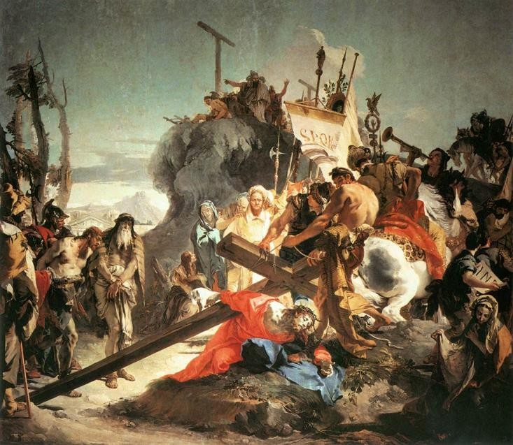1737–38
forgiveness, gained an “absolute” value in the book of Revelation.

• The setting of the Lord’s Supper and the figure of the Lamb are also marked deeply by a sacrificial
setting, although God clearly has the initiative in them.

Reflection Questions

1. In which sense is it right to talk about the salvific value of the sacrifice of Christ?

2. What are some problematic issues regarding the language of sacrifice?

3. How does a vision of sacrifice rooted in the self-offering or self-sacrifice within the Trinity bring a different light to sacrifice and our response to it?

Lecture 9. Salvation as Reconciliation

Overview

econciliation is the most “fashionable” model of salvation. Its popularity extends well beyond the realm of theology. St. Paul is the main exponent of salvation as reconciliation. This model draws on stark characteristics: enmity, agency, peace, and is used from a personal key (the
sacrament of reconciliation) to a universal one (the reconciliation of all things in Christ). Reconciliation can also entail the unleashing of a missionary impulse, or even structure an understanding of the Christian mission.
R

I. Introduction

• Reconciliation is seen in our world as highly valuable, even in a secular context, for example after bloody social conflicts.

• The basic structure of the process of reconciliation can be broken into three segments: An initial situation of conflict or enmity
A transformation through an agent

Leading to a restored peace

II. Reconciliation in the Greek Literature Prior to Paul

• In the Greek world, the vocabulary of reconciliation has generally no religious overtone and refers to the reconciliation between war-time enemies, and is not used in the context of interpersonal relationships.

• In the Greek Jewish literature, the concept would gain the meaning of reconciliation between married partners.

• A clear link is established between reconciliation and peace, for example, through the institution of the peace envoy.

• In the Septuagint, the vocabulary of reconciliation does not play a major role, and refers to the end of enmity.

III. Christ’s Work of Reconciliation According to Paul

• Paul develops the idea of salvation as reconciliation in various letters. We will highlight some features in the main ones.

Ephesians 2:11-22: the context is one of enmity, Christ is the agent of reconciliation, and human beings are first united as one body before being reconciled with God.

Romans 5:1-11: there is an articulation between the agency of God the Father and the Son, the former appearing as the ultimate agent achieved the reconciliation through Christ. Reconciliation is presented as a gratuitous gift.

2 Corinthians 5:11-21: potentially drawing on the tradition of the “peace envoy,” Paul emphasizes that reconciliation is not simply a gift to be received for oneself, but propels one to a ministry (diakonia) of reconciliation, a further proclamation to others of that message.

Colossians 1:15-20: in this hymn, a portrayal of a universal restoration of unity including the reconciliation of “all things” to God in Christ is offered. The extent of the reconciliation is then at its maximum.

IV. A Catholic Understanding of Reconciliation

• Reconciliation in a personal key: the sacrament of reconciliation

For Catholics, reconciliation is often understood in a personal key, especially through the sacrament of reconciliation.

The parable of the prodigal son constitutes a seminal metaphor in that regard.

• Reconciliation as Mission:

Reconciliation can be fruitfully deployed as a model of participation in the salvific mission of Christ. The 35th General Congregation of the Society of Jesus developed that idea in 2008 in its decree on Mission.

Reconciliation unfolds there in three dimensions: (i) Reconciliation with God
(ii) Reconciliation with one another

(iii) Reconciliation with (and in) creation

The Return of the Prodigal Son by Nikolaj
Dmitrievič Losev, 1882

This presentation of reconciliation as mission underlines the integrality of salvation, as well
as the call for human collaboration with God’s work of salvation.

Reflection Questions

1. How is Christ’s work of reconciliation grounded in the Bible?

2. What are the basic components of the process of reconciliation?

3. Why does the image of reconciliation speak powerfully to our contemporaries?

Lecture 10. Salvation as Deification

Overview

he soteriological model of deification had been upheld in the Eastern theology for centuries before being reclaimed in the West. Rooted in the nearness of God expressed progressively throughout the Bible, and epitomized in the person of Jesus Christ, fully human and fully divine,
the boldness of its language of “becoming God” testifies to a later theological development. We will look in particular at the theological presentation of deification offered by Maximus the Confessor, a theologian from the 7th century who built bridges between Constantinople and Rome.
T

I. What Does Deification or Divinization Mean?

• The notion of deification, which means “becoming God,” requires some explanation to be
understood in a Christian sense.

Eastern theology has adopted that notion as an essential one to express its understanding of
Christian salvation.

• The Greek word for deification, theosis, cannot be found in the Bible, but the idea of our ultimate nearness to God has been expressed there through other notions, as bold as “participation in the divine nature” (2 Peter 1:4).

II. Concepts Related to Deification

• A number of concepts that are themselves tangentially related to deification nonetheless shed light on the discussion of this topic:

Our nature is modeled after God’s: human beings are created in God’s image and likeness.

Sanctification and glorification: Paul uses both expressions to designate how we can share in qualities that belong to God: his holiness (think of the saints), and his glory.

Divine filiation or filial adoption: Christians pray to God as “Our Father,” are called children
of God, siblings of Jesus Christ, which signals closeness.

Trinitarian inhabitation: the word “Trinity” itself is not in the Bible, but is rooted in it, and has been widely used in the theological and spiritual tradition of the West. To use Johannine vocabulary, it indicates the mutual “indwelling” of the persons of the Trinity, and our invitation to join the dance (or perichoresis).

III. Deification in the Soteriology of the Church Fathers

• The Pseudo-Dionysius, in the 6th century, offered the first definition of deification as “the attaining of likeness to God and union with him so far as is possible.”

• In the 4th century, at a time of intense debates regarding the definition of Christ and his natures, Athanasius, in his treatise On the Incarnation, wrote that God “became man so that we might become God.” An exchange intervenes through the very person of Christ.

• A major proponent of deification: St. Maximus the Confessor

Maximus the Confessor (580–662) was a monk from Constantinople and a major theologian in the 7th century.

Because of his theological opposition to the emperor, he lived in exile in Rome for some years under the protection of Pope Martin I.

(i) He was eventually kidnapped, brought back to Constantinople, and a few years later, tortured because of his refusal to relent his orthodox views. He was rehabilitated by a council after his death.

Despite the scattered nature of many of his works, Maximus represents the maturity of the theological elaboration of the patristic notion of deification.

IV. St. Maximus’ Presentation of Deification

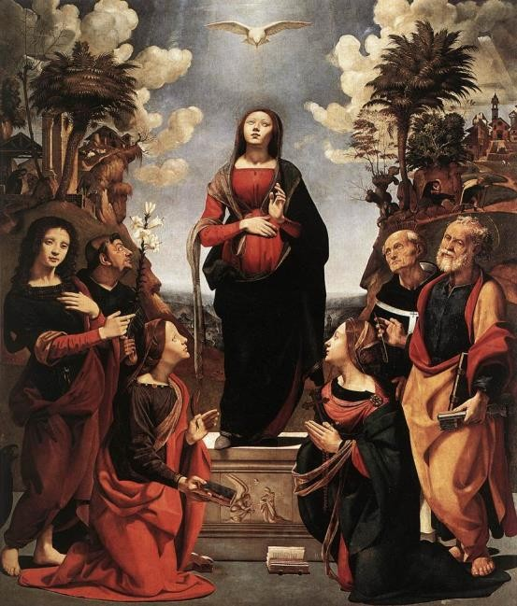• In Maximus’ anthropology, the “logos” pertains to what is immutable in the human nature, whereas the “tropos” refers the (changing) orientation.

The human nature was created as “capax Dei,” able to know and resemble God. But the history of humanity, starting with Adam, took a different route.

A new birth was necessary for humanity, to securely reorient the tropos.

(i) The Incarnation thus represents the beginning of a new era, a second nativity for human nature, in which death becomes birth to everlasting life.

• Christ opened to humanity the way of deification by his example, by the faithfulness of his tropos to God’s will, by bringing human nature to the Father, and by achieving our deification through suffering, sacrifice, and the cross.

• Deification unfolds at God’s initiative. Human beings respond to that offer in freedom, and patiently ascend towards closeness to God.
Incarnation of Jesus by Piero di Cosimo,
ca. 1505

Reflection Questions

1. In what sense are we “deified”?

2. Is deification a new concept to use when talking about salvation?

3. Which features of salvation does the notion of deification highlight?

Lecture 11. The Extent of Salvation

Overview

he Christian belief in the goodness of God and of his creation raises the question of the universality of salvation. Does God want everybody to be saved? A first element to consider is the collective dimension of salvation at work in Israel and in Christianity. The last decades have
witnessed a growing appreciation by the Catholic Church of the goodness present in other Christian denominations, and even in other religions. What is their role in salvation––in a Christian sense? Finally, considering the great number of people who do not know Christ, how can we understand his role as universal Savior?
T

I. Introduction

• Who is saved? Up to which point do the frontiers of salvation extend? Are we saved individually?
Can non-Christians be saved? These questions are not solved, but they can be explored!

• The document Ecumenical Considerations for Dialogue and Relations with People of Other Religions (2004) from the World Council of Churches uses the leitmotif “Salvation belongs to God” to highlight our posture of humility in regard to the extent of salvation.

II. The Collective Dimension of Salvation

• Our cultural setting:

Although the Western civilization values individuality, the collective dimension of life in society is also essential.

• In the Bible and the Tradition:

Israel experienced salvation first and
foremost as a people, God’s people.

The predication of Jesus encompassed strong collective elements:

(i) The Twelve

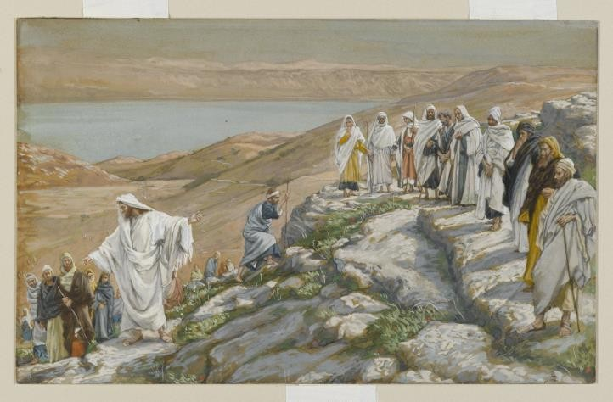Ordaining of the Twelve Apostles by James Tissot, 1886–94

(ii) The preaching of the Kingdom of God

The image of the Church as the Body of Christ highlights the necessary “wholeness” of the people of God––as seen in the communion of saints. Salvation is meant “us,” not for multiple individuals as a “me.”

III. God’s Benevolence and the Desire for the Salvation of All

• A long theological tradition identifies a single creative and divine thrust at work in creation and redemption.

A movement of universalization is present in the Old Testament, as well as in the New
Testament interpretation of the consequences of the Christ event.

Some Christian authors have advocated for a vision of universal salvation (apokatastasis), at least as a question or a hope.

IV. New Appreciation for Other Religions

• The 20th century, especially since the 1960s, has seen many initiatives on the part of the Catholic Church to improve its relationships with Christian denominations, and even to enter into dialogue with other religions.

Nostra Aetate, an important declaration from the Second Vatican Council, was a watershed moment by addressing other religions positively.

Lumen Gentium, from the same Council, also tackled the issue.

• In the recent Church teaching (Redemptoris Missio, Dominus Iesus), one central question to weigh is whether members of other religions could be saved thanks to their religion, or despite it.

V. The Mediation of Christ

• The Christian faith and its understanding of salvation cannot escape a form of mediation of Christ, which is constitutive of salvation.

• A certain mediation of the Church of Christ also has to be included in any reflection on salvation.

• The theological reflection around these issues is still on-going.

Reflection Questions

1. Is salvation only a private affair between God and the individual?

2. How can we see the role of non-Christian religions in regard to the salvation of their followers?

3. What is the interplay of the roles of the various persons of the Trinity in salvation: Father, Son, and Holy Spirit?

Lecture 12. Conclusion: Salvation as Features and
Prayer!

Overview

s a way to conclude our journey of exploration of the breadth of the Christian understanding of salvation, we will venture towards the experience of prayer about salvation, seen in words and action through the Eucharistic celebration. But first, we will expose 10 essential characteristics
of salvation, which can help to ground the contours of the notion of salvation, as well as offer criteria to assess the adequateness or completeness of any given soteriological model.
A

I. The Influence of St. Anselm

• St. Anselm of Canterbury (1033–1109) is an inescapable theological figure for the study of salvation.

He wrote the influential Cur Deus Homo (Why God Became Man).

(i) The central concept that he introduced in the soteriological discourse is that of
“satisfaction.”

As a monk, bishop, theologian, and man of prayer and reflection, he exemplifies the integration of the rule of prayer (lex orandi) to the rule of faith (lex credendi).

• In Anselm’s footsteps, we will look at the features of salvation, as well as the way in which we
“pray” salvation.

II. Features (or Criteria) of Salvation

• These features of the Catholic understanding of salvation can also double up as criteria to evaluate theological models of salvation. 10 important characteristics are highlighted:

Temporality: salvation is a reality that is not limited to only one dimension of time: past, present, or future, but encompasses all of them.

Salvation allows for growth.

Salvation intrinsically entails a collective dimension; it is not purely individual. Salvation is called to be integral.
Salvation is offered broadly, since God desires the salvation of all. Salvation liberates us from sin.
The end and core of salvation consists in union with God.

Salvation features a double agency at work in salvation: that of God and of human beings.

The whole Christ event constitutes the pivot of salvation: Incarnation, life, teaching, death, resurrection.

Salvation constitutes a Trinitarian event, in which the Father, Son, and Holy Spirit play their part.

III. Praying Salvation

• Christians do pray about salvation more often than they think:

For example, the memorial acclamation of the Eucharistic prayer presents in a nutshell essential elements of the Christian understanding of salvation.

• The act of “praying” salvation in the Eucharistic celebration is achieved through various means.
Many images and models are called to the fore and woven together.

The salvation hoped for and experienced in the Eucharistic celebration is also embodied in the use of the space, as well as the ecclesial community itself.

Through a “composition of place,” or meditation, we will walk into some of those instances
of prayer and experience of salvation that regular Church-goers are familiar with.

Review Questions

1. How do we “pray” about salvation?

2. From the list of 10 characteristics of salvation, which ones stand out to you? Which ones are emphasized? Which ones are overlooked?

Bibliography

Anselm of Canterbury, Cur Deus Homo: Why God Became Man. Beloved Publishing LLC, 2014.

Aulén, Gustaf. Christus Victor: An Historical Study of the Three Main Types of Idea of Atonement. New
York: Macmillan, 1951.

Balthasar, Hans Urs von. Mysterium paschale. San Francisco: Ignatius Press, 2000. Council of Trent. Decree on Justification (13 January 1547).
Daly, Robert J. Sacrifice Unveiled: The True Meaning of Christian Sacrifice. London: T&T Clark, 2009.

Davis, Stephen T., Daniel Kendall, and Gerald O’Collins, eds. The Redemption: An Interdisciplinary
Symposium on Christ as Redeemer. Oxford: Oxford University Press, 2004.

Dupuis, Jacques. Christianity and the Religions: From Confrontation to Dialogue. Maryknoll, NT: Orbis Books, 2002.

Gutiérrez, Gustavo. A Theology of Liberation: History, Politics, and Salvation. Maryknoll, NT: Orbis
Books, 1988.

John Paul II, Encyclical Letter Redemptor hominis (4 March 1979)

Lutheran World Federation, and Catholic Church. Joint Declaration on the Doctrine of Justification (1999): http://www.vatican.va/roman_curia/pontifical_councils/chrstuni/documents/rc_pc_chrstuni_doc_3
1101999_cath-luth-joint-declaration_en.html

McIntyre, John. The Shape of Soteriology: Studies in the Doctrine of the Death of Christ. Edinburg: T&T Clark, 1992.

O’Collins, Gerald. Jesus Our Redeemer: A Christian Approach to Salvation. Oxford: Oxford University
Press, 2007.

––––––. Salvation for All: God’s Other Peoples. Oxford: Oxford University Press, 2008.

Sesboüé, Bernard. Jésus-Christ l’unique Médiateur: Essai sur la rédemption et le salut. 2nd ed. Paris: Desclée, 2003.

